Name:

Analyzing and evaluating feedback
HIED 4010
Week 13 check for understanding

Directions: Review the feedback provided on the following two assessments from a 9th grade world history course. Assessment one is a response to a short answer DBQ question and assessment two is feedback on an annotated bibliography rubric for a National History Day project. For each, in the appropriate spaces, (1) describe the elements of the feedback that were appropriate and display effective practice and (2) explain what could have been done to improve the feedback provided (you may use red ink to make the corrections/additions if you like).

Assessment #1 – Short answer DBQ. “Using your prior knowledge and the documents provided, describe the influence the Nile River had on Ancient Egypt. Be sure to reference at least two of the documents in your response.”

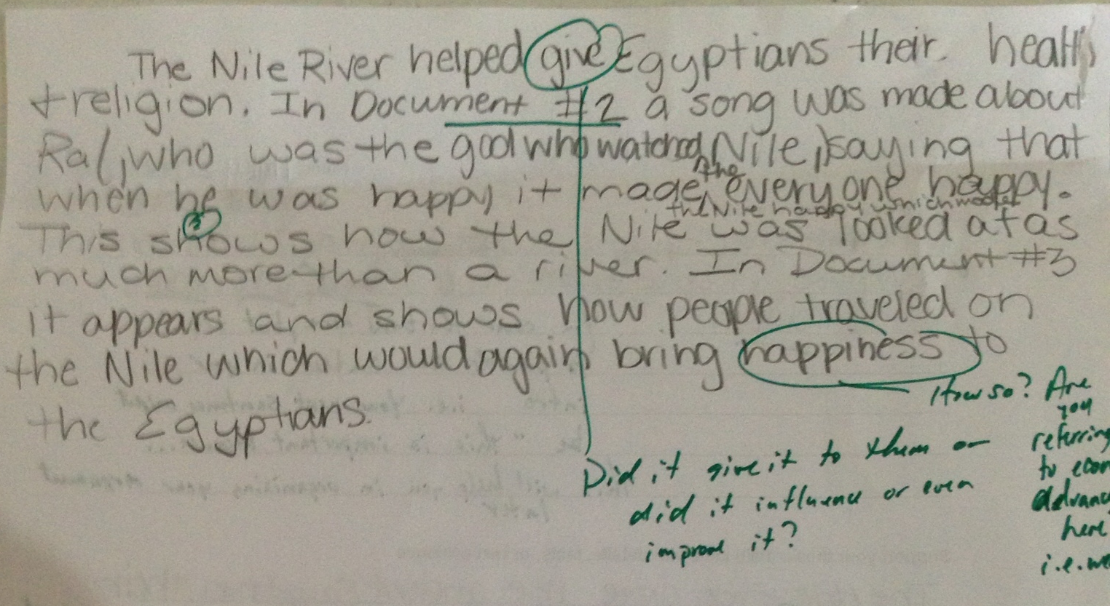

Assessment #1 – Feedback analysis and evaluation. Using what you have learned about provision of appropriate feedback through the week 13 module, in what ways does the feedback provided in the assessment above demonstrate effective practice (be specific and reference course materials) and in what ways can it be improved. If you would like to make changes/additions to the feedback on the actual assessment to illustrate your improvements, you may do so in red ink.

Evidence of effective practice: | Areas for improvement or addition:

Assessment #2 – NHD annotated bibliography
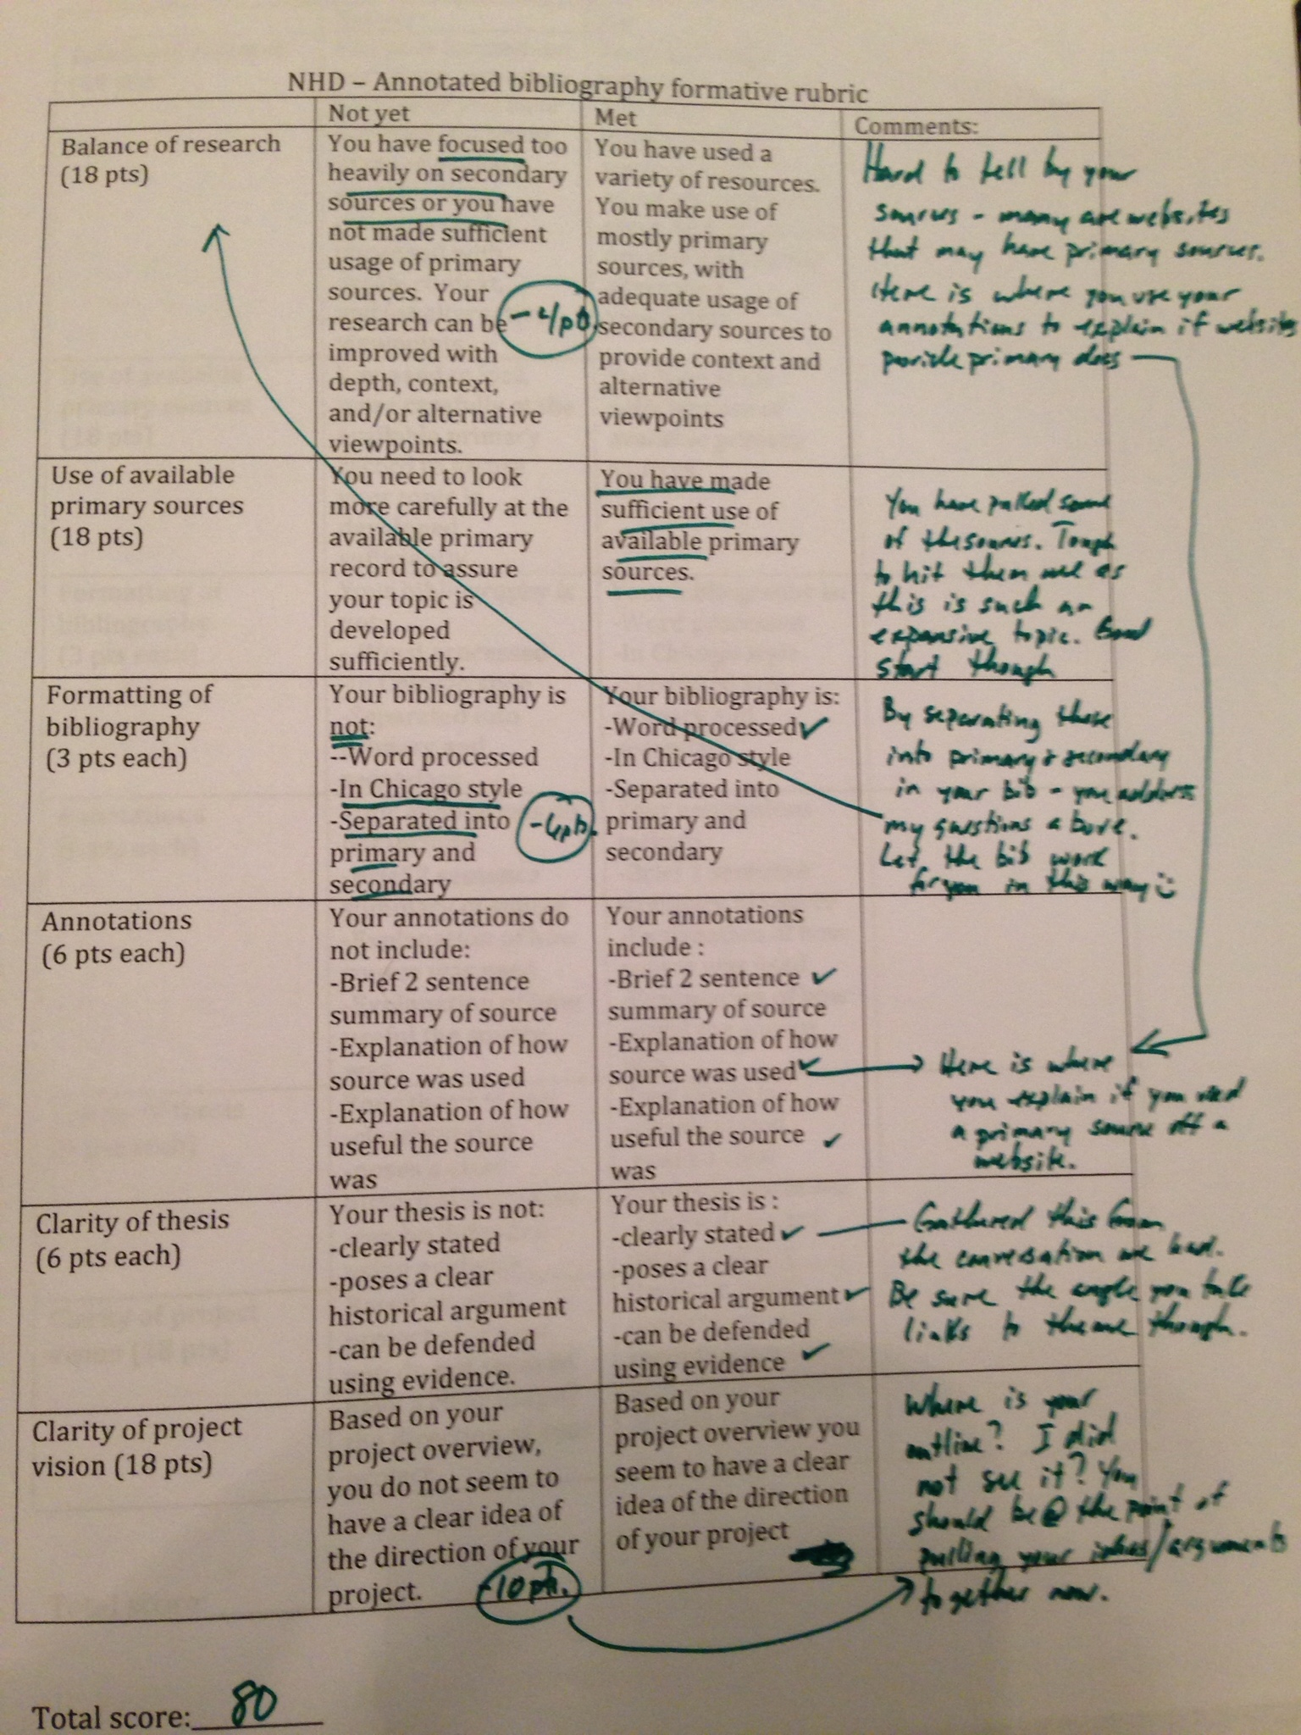
Assessment #2 – Feedback analysis and evaluation. Using what you have learned about provision of appropriate feedback through the week 13 module, in what ways does the feedback provided in the assessment above demonstrate effective practice (be specific and reference course materials) and in what ways can it be improved. If you would like to make changes/additions to the feedback on the actual assessment to illustrate your improvements, you may do so in red ink.

Evidence of effective practice: | Areas for improvement or addition:

